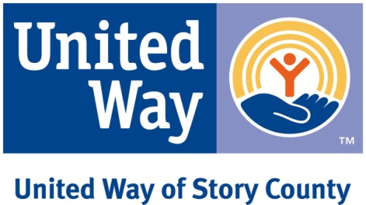

REQUEST FOR PROPOSALS
FOR
GOLF FORE KIDS GRANTS

United Way of Story County (UWSC) is announcing Request For Proposals for disbursement of proceeds from the 2017 Golf Fore Kids.

Proceeds from the Golf Fore Kids event give UWSC the exciting opportunity to fund programs and initiatives that impact the lives of Story County kids above and beyond current funding opportunities. Proposals may address expansion of programs and initiatives that are already funded by UWSC (through the ASSET process or grants process) or they may address programs and initiatives not currently funded by UWSC. Proposals for capital expenditures will not be considered.

Funding will typically not exceed $3,000 per program or initiative.

Agencies submitting proposals may or may not be partner agencies of UWSC.

Proposals should be submitted on the attached form. Incomplete proposals will not be accepted. The UWSC Allocations Committee will review proposals and make a recommendation to the UWSC Board of Directors which will make the final decisions on programs and initiatives to be funded.

The deadline for proposals is Friday, August 11, 2017 at 4:30 p.m. Announcement of the programs and initiatives to be funded will be made no later than Friday, October 6, 2017. Proposals should be e-mailed to unitedway@uwstory.org. Call 515-268-5142 with any questions.

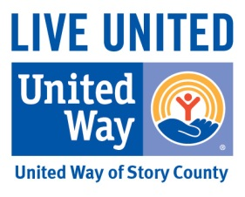

PROPOSAL FOR 2017 GOLF FORE KIDS GRANT

Section I – General Information

Date

Agency
Fiscal Agent (if applicable)

Submitted By
Name
Title
Phone No.
E-Mail Address
Mailing Address

Amount Requested $
Name of Program
If this program has received funding from a Golf Fore Kids Grant in the past, please indicate the following information about the funding awarded.
Date: Amount Received: $

Section II – Basic Program Information

Describe program to be funded, including name, description and need being addressed:

List goals and outcomes for the program:
- State the desired outcome(s)

- What tool(s) will be used to measure the outcome(s)?

- When will the outcome(s) be measured?

List any collaborating partners:

What need(s) does this program address? (Please note if this proposal meets one of the three community impact areas identified as a UWSC priority: Education, Income and Health. Also note if this proposal meets a need identified in another needs assessment you are aware of.)

Note why you need funding for this program (check all that apply and provide an explanation):
unanticipated need -
emerging need -
under-funded need -

Section III – Detailed Program Information

Population to be served, including:
- Number of constituents

- Geographical location of constituents

- Ages of constituents

- Income level of constituents

- Do any children have disabilities?

- Other pertinent details regarding population to be served

If there are eligibility requirements for participation in the program, please explain:

Timeline (attach timeline)
A. Is this a one-time or long-term program?

B. If long-term, what is the plan for sustainability?

Overall budget for program, including:

- Please ATTACH a detailed budget – include revenue sources, amounts and expenses. Note if revenue sources are committed or pending.
- Fees for participants, if any (attach sliding fee scale if applicable)

- Specific use of United Way of Story County grant funds

- Will any part of the budget qualify for matching funds? If so, please explain.

How will you publicly acknowledge the UWSC grant throughout the program?

Please submit this form electronically to unitedway@uwstory.org
If you are not a United Way of Story County partner agency, please include, in addition to this form, the following items:
- Description of organization and services provided in Story County
- List of volunteer Board of Directors

Please limit your application to a maximum of three written pages and two supporting attachments. Documents that are specifically requested above do not count in the two attachments.

The deadline for proposals is Friday, August 11, 2017 at 4:30 p.m. Announcement of the programs to be funded will be made no later than Friday, October 6, 2017.

